**There is hidden content within this document. To view them, enable the show formatting marks button in the Paragraph toolbar.**

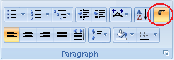

This paragraph is visible

This entire paragraph is hidden.

The table below is visible

|  |  |
| --- | --- |
| **Heading1** | **Heading2** |
| Text1 | Text2 |

The table below is hidden

|  |  |
| --- | --- |
| **Heading1** | **Heading2** |
| Text1 | Text2 |